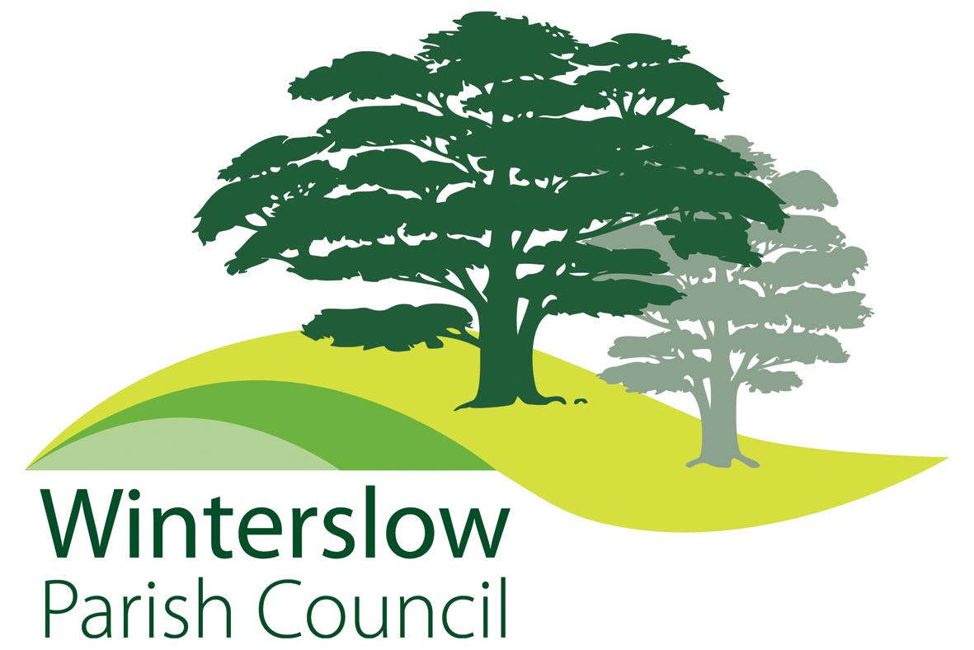 | Parish Clerk: Jane Tier  winterslowclerk@gmail.com  Phone: 07407 343387
FOOTPATHS AND SPEEDING
The Parish Council has recently received several communications from residents regarding overgrown footpaths and traffic/speeding concerns in the parish.

Footpaths – Currently the Parish Council does not have a designated Councillor for footpaths. The responsibility for footpath clearing is with the landowner.
If a footpath becomes blocked Wiltshire Council should be informed. The simplest way to report the issue is via the MyWilts app on your phone whilst at the site of the blockage. Residents are encouraged to clear any paths in the village (at their own risk), but please ensure your own safety and that of other users.

Traffic/Speeding – The Parish Council fully understands residents’ concerns about road safety but has no powers relating to highways issues. We can, however, support parishioners by seeking speed assessments, improved signage, traffic calming, changes to speed limits etc from Wiltshire Council through the Wiltshire Council Local Highways Footpath Improvement Group (LHFIG) which covers all footpaths, local roads, Byways, etc.
The reporting system is via a Highways Improvement Form which is sent to the LHFIG for them to consider and act on in accordance with County and National guidance. This can be a lengthy process.
The areas currently under review by the LHFIG are Tytherley Road, Livery Road, Weston Lane, Dunstable, Lopcombe Corner, and, recently submitted, Roman Road / Clough Lane.
For Weston Lane, several road marking changes and new signs have now been agreed (and partly funded by the Parish Council).
Lopcombe Corner – A request for a speed reduction to 40mph has been sent to the LHFIG group for their consideration.
Dunstable crossroads – Wiltshire Council contractors have undertaken a Survey at Dunstable to ascertain what measures could be taken to improve road issues at this site, Winterslow Parish Council contributed £825.00 towards the survey. (results not yet known.)

